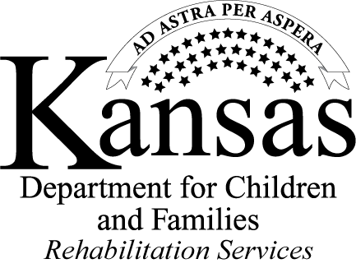
Work-Based Learning (WBL) Experience
Job Preparation Report
Completed by service provider at completion
Student Name: | WBL Site:
Pre-ETS Transition Specialist: | WBL Provider Completing Report:
WBL start date: | Student Job Title:
Dates of job preparation instruction:
Student mastered the following job preparation skills:
Student needs to work on the following job preparation skills:
Observations during job preparation instruction:

Student is committed to fully participate in the paid worked based learning opportunity. ☐ Yes ☐ No

________________________________________ ___________________________________________
Student Signature Service Provider Signature

________________________________________
Parent/Guardian (if applicable) 6/20/2018

Work-Based Learning (WBL) Experience
Job Preparation Report Instructions
Pre-ETS Transition Specialist: Name of the Pre-ETS transition specialist working with the student.

WBL Site: Employer site selected for WBL.

WBL Provider Completing Report: Name of the service provider working with the student and completing report.

WBL start date: When the student started the employment site.

Student job title: The student’s job title at the employment site.

Dates of job preparation instruction: The dates the job preparation instructions were given.

Student mastered the following job preparation skills: The skills the student obtained during the job preparation instructions.

Student needs to work on the following job preparation skills: The skills the student was not able to master or obtain during the instruction. Provide information on the reason the student was not able to obtain the skill.

Observations during the job preparation instruction: Provide observations the job preparation instructor had regarding the student during the job preparation instruction. Examples: Attendance, interactions with instructors & participants, following instructions, staying on task, if accommodations or supports were discovered that are necessary for the employer site.

