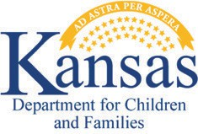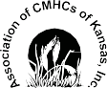



**Kansas Department for Children and Families Family Mobile Crisis Helpline**

# Services are available for all Kansans 20 years old or younger, including anyone in foster care or formerly in foster care.

**Call, text, or chat with the helpline at**

**833-441-2240**

# **A wealth of resources at your fingertips**

Over the phone support and problem solving

to help resolve a child’s behavioral health crisis

Over the phone support with referral to community resources or a recommendation to engage

in stabilization services

In-person support via mobile crisis response if the crisis cannot

be resolved over the phone

In emergency situations, EMS, law enforcement and/or the mobile crisis response unit will be contacted to assist



A02273KSMENCBH