**Instructions for PPS 5410A Data Collection**

The 5410A must be completed and submitted electronically. Do not submit handwritten 5410A’s to Eligibility Specialists, they will not be accepted.

**Please complete and submit the 5410A to IV-E Eligibility Specialists as soon as possible. Consult your CPS supervisor or an Eligibility Specialist regarding your Region’s expectations on submitting the 5410A timely.** Eligibility Specialists have **30 calendar days** per PPS Policy to complete their eligibility determination.

**\*\*Tip for completing the 5410A** – take a copy of the document with you to Court, the 24-hour meeting, or any parent meeting and ask these questions. The answers are very important to IV-E eligibility staff and a vital part of our determination.

**Child in Custody Information: Page 1**

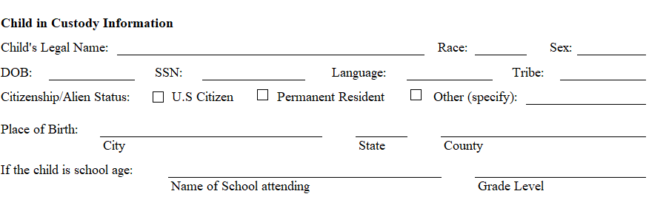

Please make sure you answer all questions, **do not leave blanks**. If the parents will not provide information, please indicate this on the form by entering “**Unable to Obtain**” in the space provided.

**Child’s Legal Name** - needs to match the Birth Certificate/FACTS case.

**Place of Birth** – provide City, State and County. Do not put “Unknown” or leave blank. If you do not have this information, please type in “**Unable to Obtain**”.

Mark appropriate **Citizenship/Alien Status** box. **Reminder:** Permanent residency is not the same as legal Citizenship. See **PPM 5911, 2. Citizenship** for information regarding difference between legal U.S. Citizen and non-citizen immigrants and required documents for proof of citizenship.

**If child is of school age -** Provide school information or enter N/A if not applicable.

**Section 1 Legal Information:**

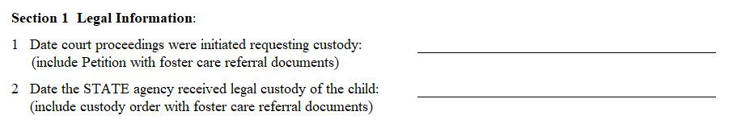

1. Date Petition filed with court.
2. Date of Initial Custody Order placing child in DCF custody (Ex Parte Order, Temporary Order of Custody, etc.)

**Section 2 Removal Information:**

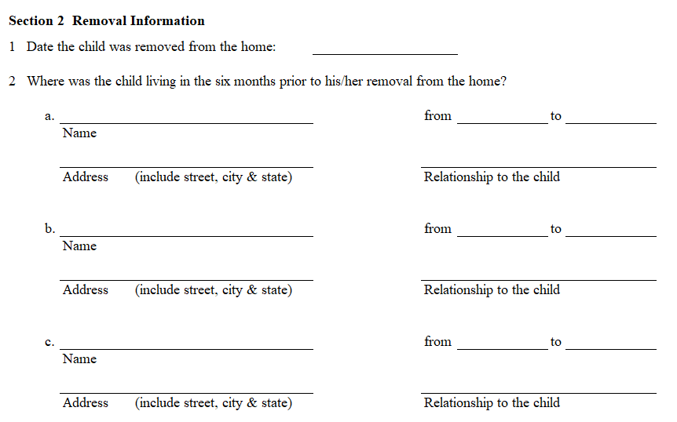

1. **Date the child was removed from the home:** The date child was removed from home or date of custody order. The removal date may be the date of the initial custody order (Ex Parte Order, Temp Order of Custody, etc.) if the foster care referral was made the same date. If the child was removed prior to the date of the custody order (due to placement in PPC by law enforcement) or after the date of the custody order, enter the date child was removed from the home.

1. **Where was the child living in the six months prior to his/her removal from the home?**

Please indicate **all** homes where child lived in the six months prior to removal date. That information must be entered in this section.

**Example**: The child lived with grandparents at time of custody order on 1/15/24 and had been living in their home since October 2023. Child had lived with Mother from birth prior to moving in with grandparents. The first entry (a.) should be the grandparents’ information, address, relationship to child, and the dates the child lived in their home. The **From** and **to** section should reflect this information: **from 10/1/23 to 1/15/24**.

The second entry (b.) should be Mother’s name, address, relationship, and the dates child lived with mother on the second entry: **from birth to 9/30/23**.

**Section 2 Removal Information Continued: Page 2**

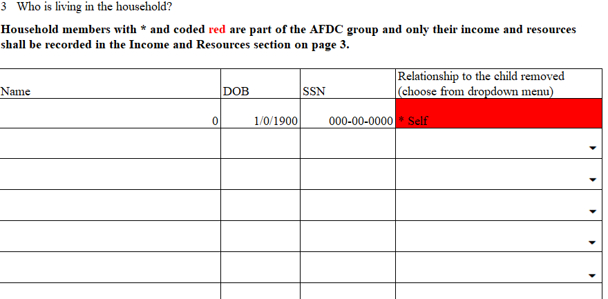

1. **Who is living in the household?** The information should be regarding the home the child was removed from. (**The cursor must be in the cell in the Relationship column in order to click on drop-down menu and see the choices.)**

**Example**: Using the same example used for Section 2 (above), the child’s removal home depends on if the child was physically removed from grandparents’ home on 1/15/24 or if he was left in grandparents’ home, If child was left in grandparents’ home, mother’s home is the removal home. If grandparents’ home is the removal home, grandparents’ household information should be entered on this page. If mother’s home is the removal home, mother’s household information is to be entered on this page. If there are questions regarding this situation, please consult IVE Eligibility supervisor or an Eligibility Specialist for assistance.

Every referral should include a current and updated 1000 Face sheet for the event that led to the current removal. This is to be included in the documents sent to the Eligibility Specialists at the time of the foster care referral.

**Name:** First & Last name as is on BC/Facts

**DOB:** for all members “living” in the home (this also includes non-related persons)

**SSN:** for all members “living” in the home (this form will auto populate the dashes)

**Relationship to child removed:** **Note** It is very important to use the drop-down menu for this column, as the form was developed to indicate members of the AFDC group by relationship and is indicated by the * symbol.

All these fields will auto populate to page 3, and the members with * are members of the AFDC group. Income and resources for individuals with the * are to be reported in this section.

**Section 3 Income and Resources:**

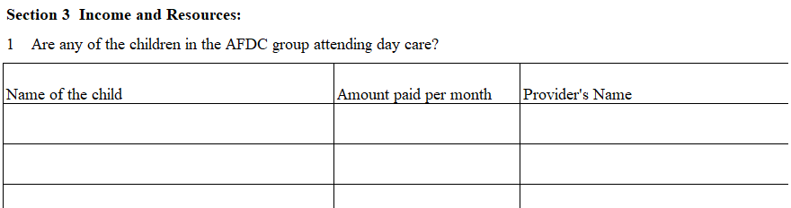

1. If no children are in daycare put N/A. If children in the AFDC group are in daycare, enter the information required.

**Section 3 Income and Resources continued: Page 3**

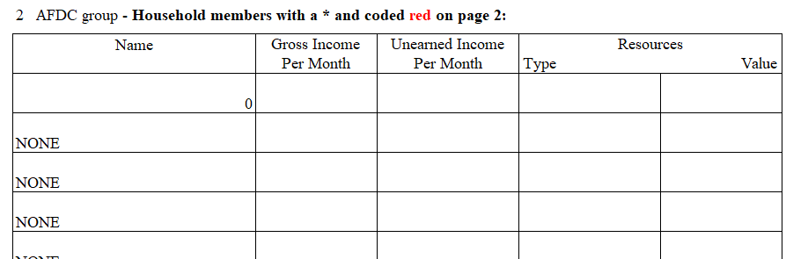

As much information as possible is needed regarding employment, as it affects the outcome of the entire determination. You are the front line, our best and closest resource for information. We understand there are times the parent won’t cooperate; however, we need to know you are doing your best to get us this information. If you are unable to obtain the information, please state this on the space provided and do not leave information blank.

**If you could not obtain the wage information, please inform us in the email when you send the 5410A, so we can include it in the file.**

**2. Income and Resources of AFDC Members:** anyone with * from page 2.

List income for parents listed in this column (populated from page 2 of Household members).

Please indicate the type of **Unearned Income** (unemployment benefits, SSI/SSA, child support, pensions, alimony, gifts from friends/family, etc.). **Gross Income** is wages earned from employment (job, self-employment, tips, bonuses, etc.)

Do not list the income under resource type. Resources are savings accounts, vehicle, assets, etc.

\*\***Note**\*\* Temporary Assistance to Families (TANF) and Food Assistance (FS or FA) are not countable resources or income and are not required to be listed on the 5410A.

If you have questions regarding income and resources, please contact IVE Eligibility supervisor or an Eligibility Specialist for assistance.

**Are the parent(s) employed?** Check “**Yes”** or “**No”** boxes for parent or step-parent living in the removal home. You will only complete this section if the parent/step-parent resides in the removal home. **If the parent is absent from the home, do not put their employment information in this section.**

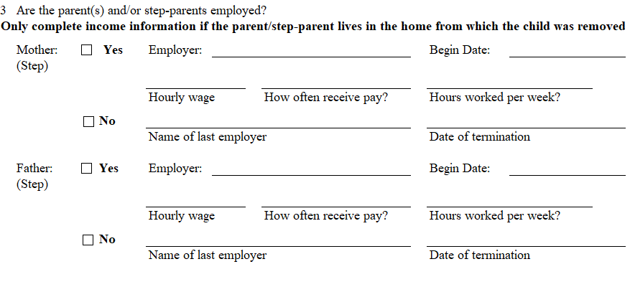

**Employer**: Do not leave information blanks or enter “Unknown”. If you cannot obtain the needed information, please enter “Unable to Obtain”. Blanks and “Unknown” make it unclear if an attempt was made to gather the information.

**Begin Date**: Can be the month and year, or just the year, as we need as much info as possible.

**Hourly wage**: If a parent tells you they are employed, please ask their hourly wages, as this helps us calculate gross income.

**How often receive pay**: Most paychecks are received Bi-weekly, Monthly, Bi-monthly, or Weekly. This information helps us calculate the gross monthly income.

**Hours worked per week**: If employed, please ask how many hours they work per week. This helps us calculate gross monthly income.

**Name of last employer and Date of termination:** If the parents are unemployed, provide the name of their last employer and the date of termination in this section on page 3.

**Section 3 Income and Resources Continued: Page 4**

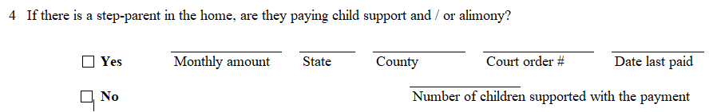

1. **\*\*\*\*If no step-parent is living in the removal home, leave this section blank and do not check “Yes” or “No”.**

**Section 4 Deprivation:**

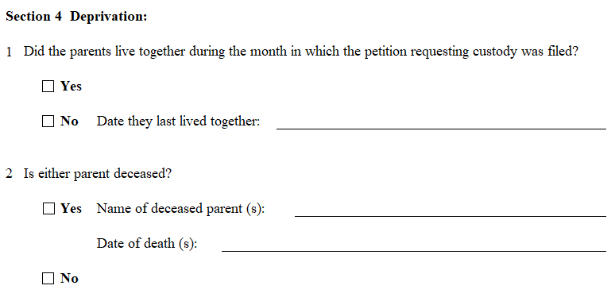

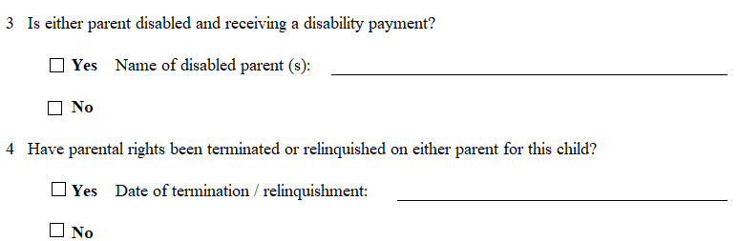

1. If “**No**”, do not leave blank or enter “Unknown”. “**Unable to obtain**” is acceptable.

2. If “**Yes**”, enter the name of the deceased Parent/ Date of death. If information cannot be obtained put “**Unable to Obtain**”.

3. If “**Yes**”, enter the name of disabled parent.

4. If “**Yes**”, provide date if one of the parent’s rights have been terminated for this child.

**Section 5 Child Support Enforcement Information: Page 5**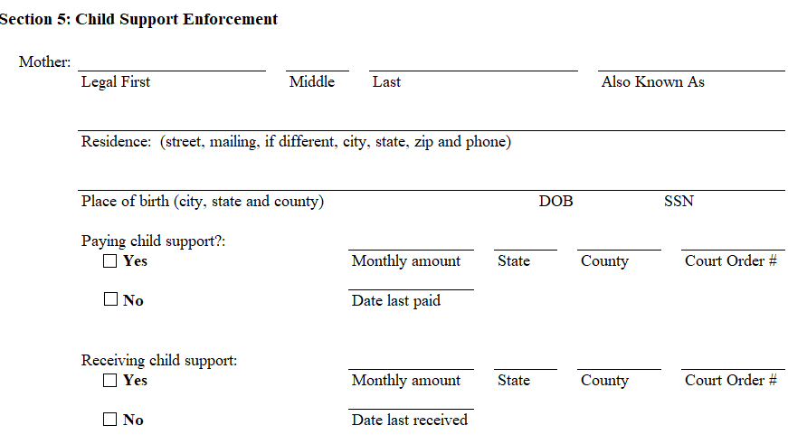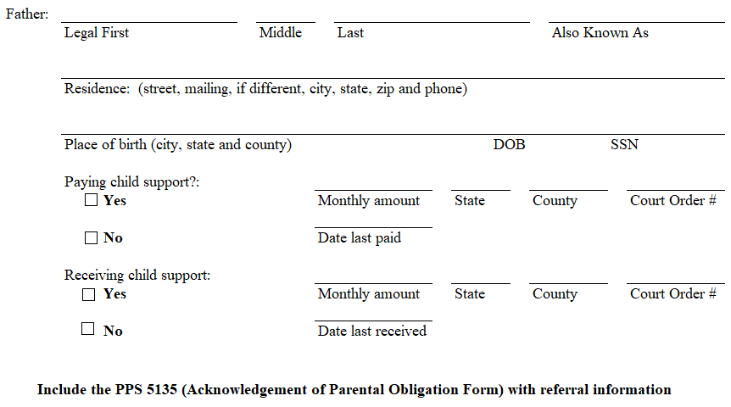

**Mother/Father**: Complete all fields – please do not leave blanks. Enter **“Unable to Obtain”** if the information cannot be obtained. Check “**Yes**” or “**No**” boxes.

**\*\*Note** - a PPS 5135 Parental Obligation is to be included with every foster care referral. Eligibility workers are required to send them to Child Support Services.**

**Section 6 Health Insurance Information: Page 6**

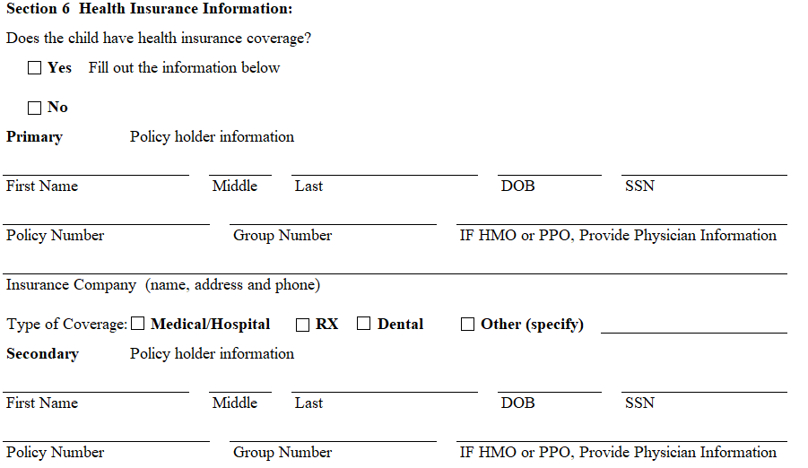

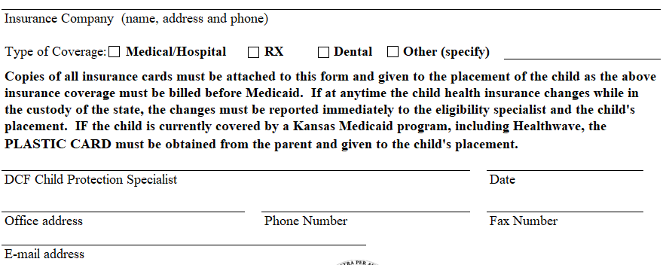

**\*\*NOTE\*\***

This section only refers to Private health insurance and only needs to be completed if the child is covered under insurance through their parent’s employer. If the child does have private insurance, a copy of the card is to be provided to the Eligibility staff.

If the child has state insurance, do not check boxes for “**Yes**” or “**No**”.